|  |  |
| --- | --- |
| Sprint 2 | WEB UI FOR ADMIN |
| Team ID | PNT2022TMID48141 |
| Project Name | Project – Personal Assistance for Seniors Who Are Self-Reliant |

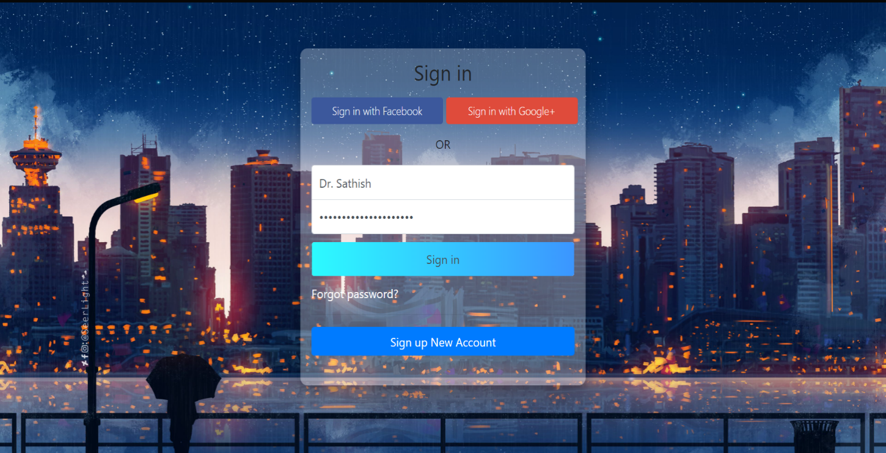

**SIGN UP :**

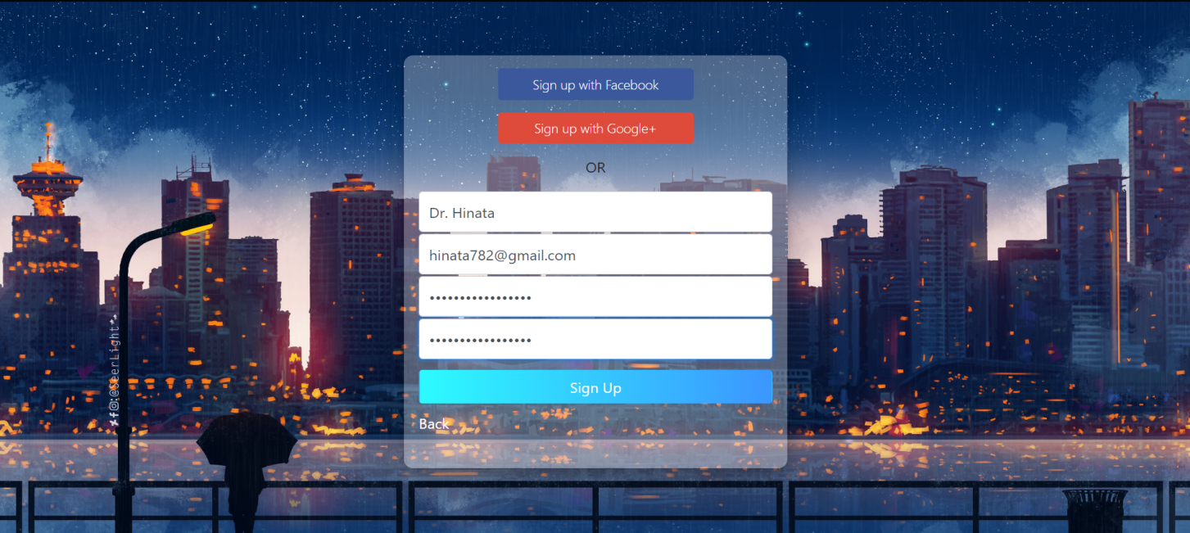

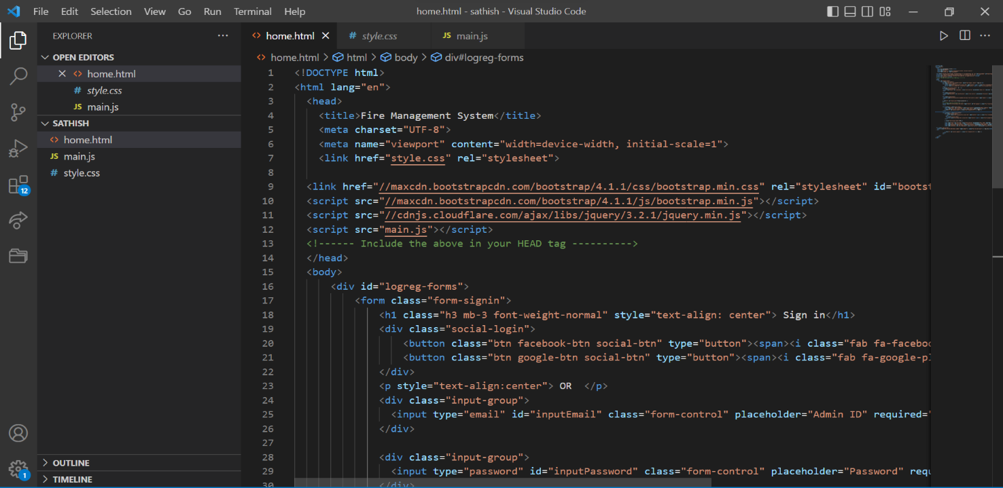**CODE:**

F